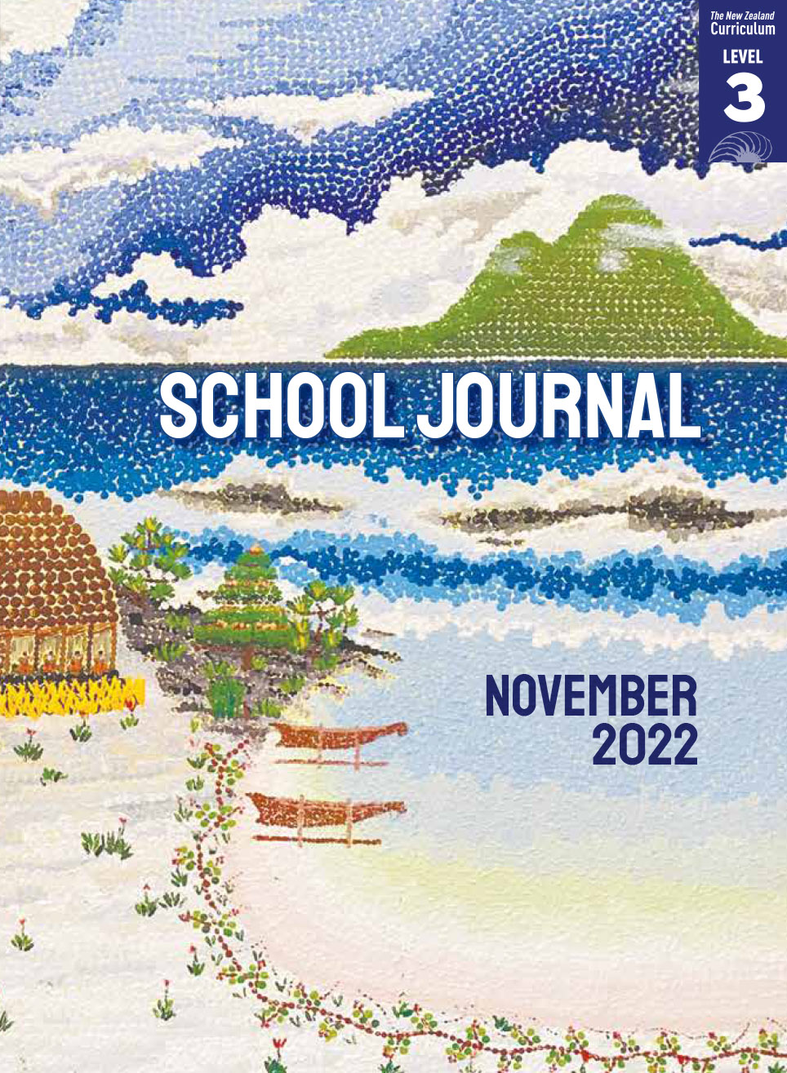

School Journal

Level 3, November 2022

**Reading level year 4**

# Living by the Maramataka

by Haukura Jones

The[Learning Progression Frameworks](https://curriculumprogresstools.education.govt.nz/lpf-tool/) (LPFs) describe significant signposts in reading and writing as students develop and apply their literacy knowledge and skills with increasing expertise from school entry to the end of year 10.

## Overview

Maramataka is the Māori calendar, a knowledge system that can be traced back to Hawaiki. For generations, tūpuna have used changes in the natural world as a guide for planting, harvesting, fishing, and hunting and for many other communal activities. Today, knowledge of maramataka continues to be used as a guide for living in harmony with the environment and looking after it as kaitiaki. During the reading and any subsequent activities, ensure that you value the existing knowledge some ākonga Māori have about the maramataka.

A PDF of the text is available at [www.schooljournal.tki.org.nz](http://www.schooljournal.tki.org.nz)

## Themes

“Living by the Maramataka” connects to the theme of kaitiakitanga. Other texts in this Journal (and the levels 2 and 4 journals for November 2022) also focus on this theme This article is scaffolded for extra support and is designed to build knowledge and introduce the important ideas and vocabulary connected with the theme of kaitiakitanga. On page 5 of this TSM, there is an overview of all the texts in this Journal, including a list of themes for each text. There is also a link to the audio for this text, which provides further support so ākonga can revisit the story as often as they   
need to.

The theme of kaitiakitanga refers to guardianship, care, protection of land and water, and the passing on of traditional knowledge.   
In te ao Māori, people are believed to have whakapapa connections within the natural world. All people share a responsibility to care for the environment. Among the texts that focus on kaitiakitanga, there are stories and articles that convey the message that if we care for nature, nature will care for us.

**Other themes that can be explored in this text include:**

• Astronomy • Tūpuna • Ecology • Cycles of time

## Texts related to the theme

**“Listening to the Land”** *Connected* L3 2018 | **“Te Tapa Ingoa”** *Connected* L3 2018 | **“Rōngoa for the Land”** *School Journal* L4 2020 | **“Namu and Waeroa”** *School Journal* L2 May 2012 | **“The Pā That Matawhero Built”** *School Journal* L3 June 2022 | “**Ngā Pepeha a ngā Tūpuna”** *School Journal* L4 June 2022 | **“Night Light”** *School Journal* L2 May 2016 | **“Why Is the Moon Upside Down?”** *Connected* L3 2013 | **“Waiting”** *School Journal* L3 Aug 2020

## Strengthening reading behaviours (what to notice)

|  |  |
| --- | --- |
| Text structure and features | Requiring students to: |
| * Technical information *It’s best to catch tuna, for example, on days when the moon is partly lit and the nights are darker.* (page 29) | * use information from their pre-reading discussion and activities, along with close reading of the sentence and surrounding text, to understand how the maramataka works and how people use it to guide activities such as eeling |
| * Abstract ideas  *Maramataka are different from one iwi to the next.* (page 26) * Words and phrases in te reo Māori (see below) | * reread this paragraph (page 26) and look for key words, phrases, and examples to identify why different iwi developed different versions of maramataka * use in-text translations, knowledge of te reo, and contextual clues to work out unfamiliar vocabulary. |

|  |  |
| --- | --- |
| Vocabulary | |
| Possibly challenging words and phrases  Celestial terms  Names  Te reo Māori | traced, taonga tuku iho, perish, generations, natural world, versions, degree, Māori studies, harvest, crop, eeling, breeding ground, reappear, horizon  maramataka, rā, whetū, aorangi, marama, Matariki, Te Mātahi o te Tau, Puanga, Rigel, Puaka, Pleiades, Seven Sisters  Heeni Hoterene, Horowhenua, Ngāti Raukawa ki te Tonga, Hawaiki, Ngāi Tūhoe, Tūtakangahau, Northland, Reuben Taipari Porter, Ngāti Kahungunu, Ngāti Hine, Awanui, Manawatū, Taranaki  iwi, whānau, koro, kaitiaki, tūpuna, maramataka, īnanga, rā, whetū, aorangi, marama, pōhutukawa, tohu, hapū, rangatira, ngahuru, takurua, raumati, kōanga, ngā kaupeka o te tau, kūmara, tuna, moana, Pipiri |
| Helpful prior knowledge (pre-reading and introducing the text) | |
| * Some knowledge of astronomy, for example, Earth takes about 365 days to orbit the sun, it takes about thirty days for the moon to orbit Earth, and there are about twelve lunar cycles in a year. * Understanding that time can be measured in different ways, with a focus on the difference between solar calendars (which are based on the time it takes Earth to orbit the sun) and lunar calendars (which are based on phases of the moon). You could make connections with festivals where their dates are set using lunar phases, for example, Chinese New Year, Diwali, Eid, and Easter. * Some understanding of the concept of kaitiakitanga and the different ways Māori understand and relate to the natural environment. * Some knowledge of traditional sources of kai such as īnanga, kūmara, tuna, and kaimoana. | |

## Possible reading and writing purposes

* Identify how and why Heeni is a kaitiaki
* Understand the different ways that maramataka can be used
* Identify and discuss the relationship between maramataka and kaitiakitanga
* Explain why there are different versions of maramataka

See *Effective Literacy Practice in Years 5–8* for suggestions on using this text with your students ([Teaching comprehension](https://literacyonline.tki.org.nz/Literacy-Online/Planning-for-my-students-needs/Effective-Literacy-Practice-Years-5-8/Teaching-comprehension)) and for suggestions on teaching reading ([Approaches to teaching reading](https://literacyonline.tki.org.nz/Literacy-Online/Planning-for-my-students-needs/Effective-Literacy-Practice-Years-5-8/Approaches-to-teaching-reading)). If you need further information for some students, you could refer to *Effective Literacy Practice in Years 1–4.*

## Possible curriculum contexts

## This text has links to level 3 of the New Zealand Curriculum in science (The Living World) and social sciences.

## Understanding progress

The following aspects of progress are taken from the [Learning Progression Framework](https://curriculumprogresstools.education.govt.nz/lpf-tool/)s (LPFs) and relate to the specific learning tasks below. See the LPFs for more about how ākonga develop expertise and make progress in these aspects:

* Acquiring and using information and ideas in informational texts
* Making sense of text: using knowledge of text structure and features
* Reading to organise ideas and information for learning
* Using writing to think and organise for learning.

## Strengthening understanding through reading and writing

**After the first reading of “Living by the Maramataka”,** **select from the following suggestions and adapt them** according to the strengths, needs, and experiences of your ākonga. Most of these activities lend themselves to ākonga working in pairs or small groups. Use appropriate teaching strategies that support your ākonga to complete the activities you select.

* MODEL how to identify ways that knowledge of maramataka can be applied in daily life, for example, by scanning the text for specific activities. Discuss why the use of maramataka has changed over time, for example, as people from the Pacific adapted to the environment of Aotearoa New Zealand or in response to changes in the ways people live.
* PROMPT ākonga to make connections with their knowledge about tohu (signs) in the natural world that signal a new season or year is on its way. Explore how these tohu might differ depending on where you live, drawing on the experiences of ākonga who have lived in different parts of the country or world. Make comparisons with the tohu conveyed in the text and illustrations on pages 26 and 27.
* MODEL how to use the descriptions in this [Te Papa Maramataka poster](https://www.tepapa.govt.nz/sites/default/files/maramataka-poster.pdf) with the images on pages 26 and 27, for example, by identifying key words in each description and looking closely at the detail in the images. You could extend this activity by having ākonga work in groups to cut out the twelve descriptions in the poster (without including the names of the months) and then match them to each season or even each month in the diagram.
* ASK questions to explore the concept of “taonga tuku iho” – knowledge that is passed down from the ancestors. *How has knowledge of the maramataka been passed on? How is this similar to or different from other ways of sharing knowledge, for example, pūrākau, whakataukī, waiata, and whaikōrero?* *What is the relationship between the passing down of knowledge and kaitiakitanga?*
* DIRECT ākonga to make connections between the examples of Māori knowledge, culture, values, and beliefs described in this article and the mātauranga Māori described on slide 2 of the text [*Listening to the Land*](https://docs.google.com/presentation/d/1hOLxtZY1wzEFRokzS2bAk0OvApyvJXh5896JgnDOt-k/present?slide=id.g16b825e197_0_11)(*Connected* L3 2018).
* USE the graphic organiser on page 4 of this TSM as a tool for ākonga to reflect on the relationship between kaitiakitanga and maramataka. Support ākonga to find places in the text that show how maramataka can be used to protect the environment. Examples can be used in more than one column. An example has been provided.
* INVESTIGATE the traditions of local iwi near your school that relate to or are influenced by their observation of natural phenomena. If you have a relationship with your local iwi, you could ask how they would like to support ākonga knowledge. (If you don’t have a relationship, contact your regional office of the Ministry of Education for help in making contact with an iwi.)
* PROMPT ākonga to make a class action plan to help them harness their knowledge about the maramataka and ways to keep nature in balance. What actions could they take to initiate positive cycles of behaviour in the school in relation to the environment?

## If ākonga need extra support

* Support ākonga to make connections with their knowledge and experiences of Matariki or Puanga and with the different phases of the moon. Explore how the phases of the moon are used to determine when different festivals occur, such as Chinese New Year, Diwali, Eid, and Easter.
* Prompt ākonga knowledge of astronomy by viewing a model, diagrams, photographs, or a short video that illustrates Earth orbiting the sun, the moon orbiting Earth, and the other celestial bodies mentioned in the text. Discuss what the celestial bodies are called in different parts of the world. Draw out ākonga understanding of how the lunar cycle connects to the different calendars.
* Have ākonga highlight any unfamiliar vocabulary, sentences, or concepts they find confusing. Discuss strategies for figuring them out, such as using decoding skills, their knowledge of vocabulary and text structure, as well as context clues.
* Provide visual images or definitions to scaffold the understanding of the words in te reo as ākonga listen to or read the article and/or the Te Papa Maramataka poster. These could be reused to create vocabulary-matching activities, for example, matching the image to the word, or to play games such as bingo or Go Fish. Ākonga could also add translations in their first languages. Begin with more familiar words such as whānau, koro, and whetū, before moving on to abstract terms such as tohu and kaitiaki. Ākonga may need support with the meaning of the names of the months in te reo on page 27, which are used to represent monthly activities. Ākonga may be more familiar with transliterations of the names of the month.
* Ask ākonga to read a section of text from the Te Papa Maramataka poster, create a simple sketch or diagram of what they have read, and then label it using words (evidence) from the text. Give each ākonga a different section to illustrate. Discuss their sketches, explaining how the words in the text guided their drawings. This could also be done as a jigsaw activity.
* Remind ākonga of the strategies they can use to tell the difference between a place, a person, or a hapū or iwi. For example, the names of many iwi begin with Ngāti, references to people are often followed by a verb, and place names are often preceded by the word “in”. Display a map of Aotearoa New Zealand that shows the location of different iwi.
* Support ākonga to make connections between the information in the text and that in the diagrams, illustrations, and photographs. A simple graphic organiser could help to link the information between these sources.
* Share-read with ākonga where necessary and provide the audio for them to revisit the article as often as they need to. Some ākonga may benefit from listening to the audio before reading and discussing the ideas with others.

## Reflecting on the text: **“Living by the Maramataka”**

**What is the relationship between maramataka and kaitiakitanga?**

|  |  |  |
| --- | --- | --- |
| **Te hauora o te tangata** The health of the people | **Te hauora o te taonga** The health of species and ecosystems | **Te hauora o te taiao**  The health of the wider environment |
|  |  |  |

|  |  |  |
| --- | --- | --- |
| **Te hauora o te tangata** The health of the people | **Te hauora o te taonga** The health of species and ecosystems | **Te hauora o te taiao**  The health of the wider environment |
| *In the past, maramataka helped people to know when to plant kūmara so they would have plenty of food for winter.*  *Matariki is a time to rest and spend time with whānau, which is good for wellbeing*. | *Ngāti Hine use maramataka to track tuna so they can help them return to their breeding grounds.* | *Maramataka are based on the idea of using the environment in a respectful way rather than changing or controlling it.* |

## School Journal | Level 3 | November 2022

Exploring a theme: The texts marked with a  share the theme of kaitiakitanga.

|  |  |  |  |  |
| --- | --- | --- | --- | --- |
|  |  | **Reading level** | **Themes** | **Curriculum  links** |
|  | Living by the Maramataka ARTICLE  For generations, Māori have used changes in the natural world as a guide for planting, harvesting, fishing, hunting, and for other communal activities. Today, knowledge of maramataka continues to be used as a guide for living in harmony with the environment and protecting it as kaitiaki. | Year 4 | Kaitiakitanga  Mātauranga Māori  Astronomy  Time | Science (The Living World)  Social sciences |
|  | **A Good Kaitiaki** POEM  A humorous poem about a child cleaning the family’s frog tank. | Year 6 | Kaitiakitanga  Responsibility  Humour  Pets | English |
|  | Kāinga STORY  Grace’s younger sister sometimes resents having to look after her older sibling. One day, when she takes Grace to see the gannets, she mistakenly thinks a boy is laughing at Grace and feels indignant about the way people perceive her sister. She then realises her mistake and shares a moment of joy watching the birds with Grace. | Year 5 | Kaitiakitanga  Whānau  Diversity  Tuakana–teina | Health and PE  English |
|  | The Kaukalaikiki **Girl** ARTICLE  Pusi Urale has found a way to explore her kaukalaikiki-ness through her bold, vibrant art. Her curiosity and fearlessness means Pusi is always exploring new ideas and asking questions. Based on early memories of Samoan life, Pusi’s unique style of painting and tapa-cloth making convey Pacific stories, designs, and patterns. | Year 6 | Creativity  Persistence  Curiosity | The arts:  visual arts  Health and PE |
|  | Balancing Act STORY  “She likes dance at lot – loves it, mostly – although lately, it’s felt like a chore. She’s not sure any more … Her mum would probably just remind her how good she is. Hana knows she’s good. But it’s hard being good. It takes a lot of effort.” | Year 6 | Wellbeing  Self-care  Extra-curricula activities/hobbies  Ballet/dance | Health and PE  English |
|  | Best Wedding Ever story  Levi’s fathers are getting married, and everyone has been fussing for weeks. On the wedding day, as the family lurches from one mishap to the next – from an invasion of sandflies to Papa splitting his pants – Levi’s eyes are only on the cake! | Year 6 | Family, whānau  Humour  Special occasions | English  Health and PE |
|  | Sumner Beach Student Writing  Gentle waves brush onto my feet. Grey sand crunches between my toes … | N/A | Natural world  Environment | English |
|  | All Rise PLAY  A “playful” take on “The Little Ren Hen” that sees her presiding as judge and jury on the crimes of her friends Dog, Cat, and Rat. | Year 6 | Folk tales  Humour | English  The arts: drama |